

Midterm

Kate Moreland

kem0149

9/29/25

# Executive Summary

The following report shows the process of extracting files from a disk image that was taken from an art theft. The files were recoved from one FAT16 partition and one NTFS partition.

# Table of Contents

This section should begin on a new page. The table of contents below is generated using the "References" menu.

Table of Contents

Executive Summary 1

Table of Contents 2

List of Figures 3

List of Tables 7

1Detailed Analysis of Partition Allocation 9

Partition 1 10

Partition 2 12

Detailed Analysis of the Recovery Process 12

2.2.1Partition 1 File 1 13

2.2.2Partition 1 File 2 15

2.2.3Partition 2 File 3 15

2.2.4Partition 2 File 2 15

3Description of Analysis Techniques Utilized 15

4Results and Discussion 15

5Conclusions and recommendations 15

6Acknowledgements 15

7References 15

Appendix A: Place the title of appendix here 15

# List of Figures

Bastile.png

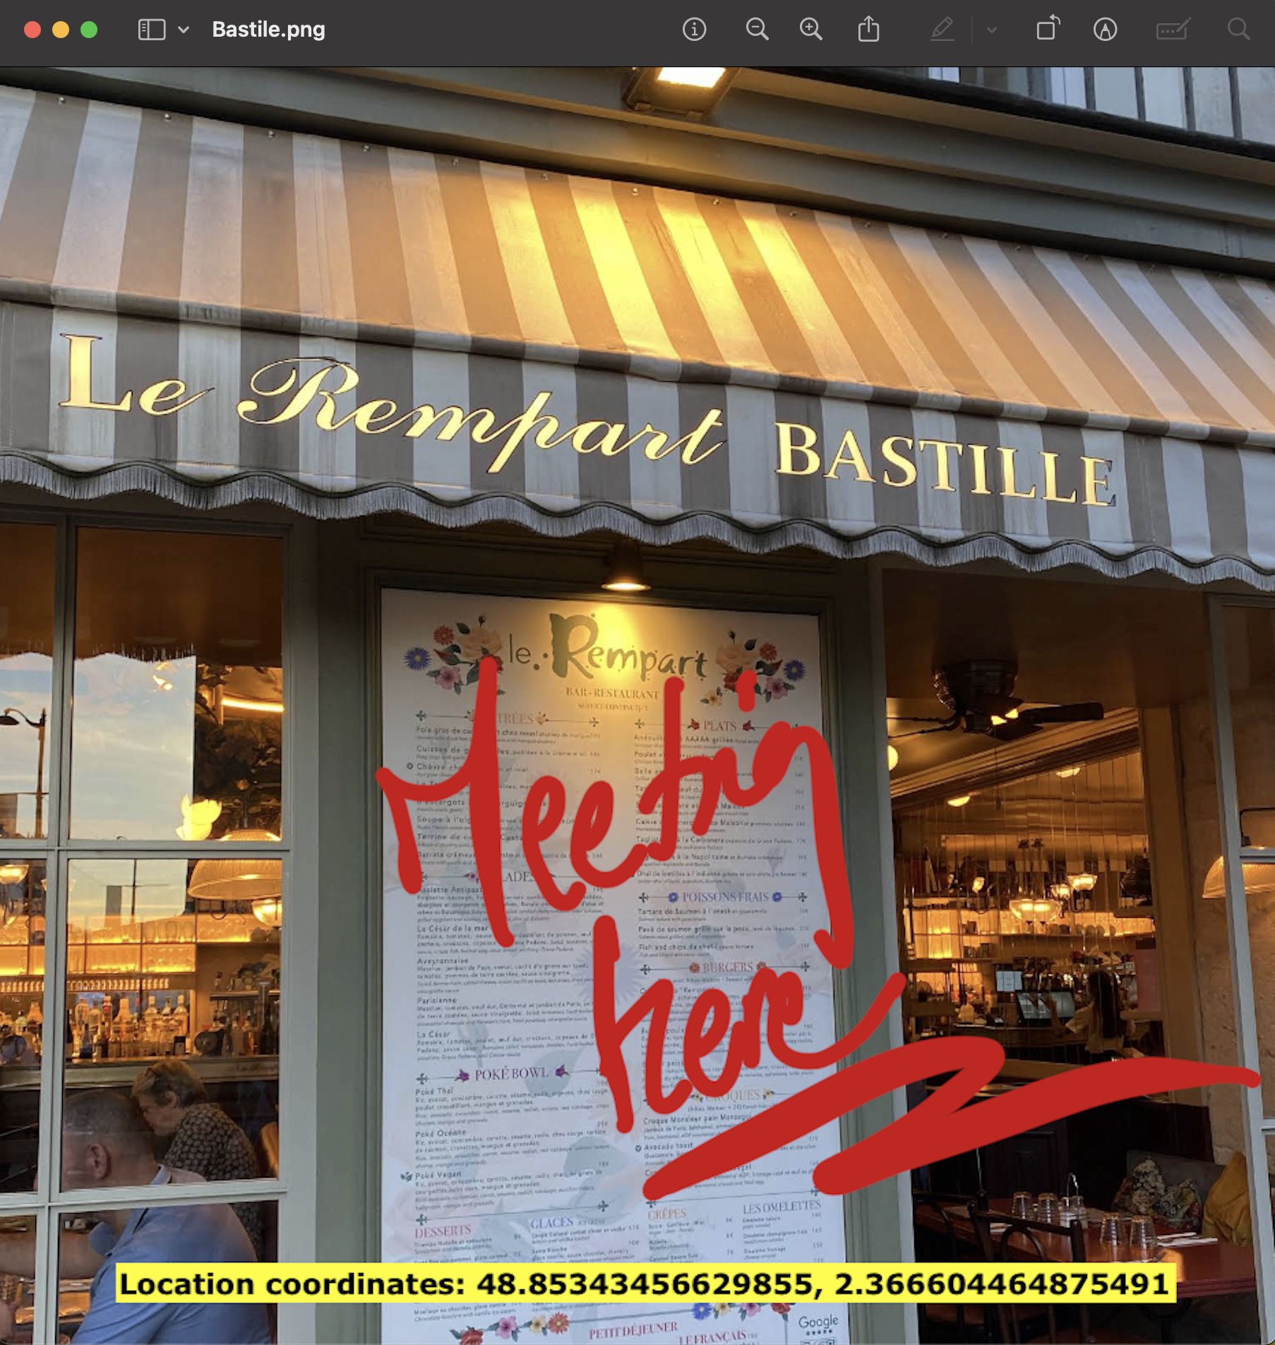

Registrar.zip

move-time.png (in registrar)

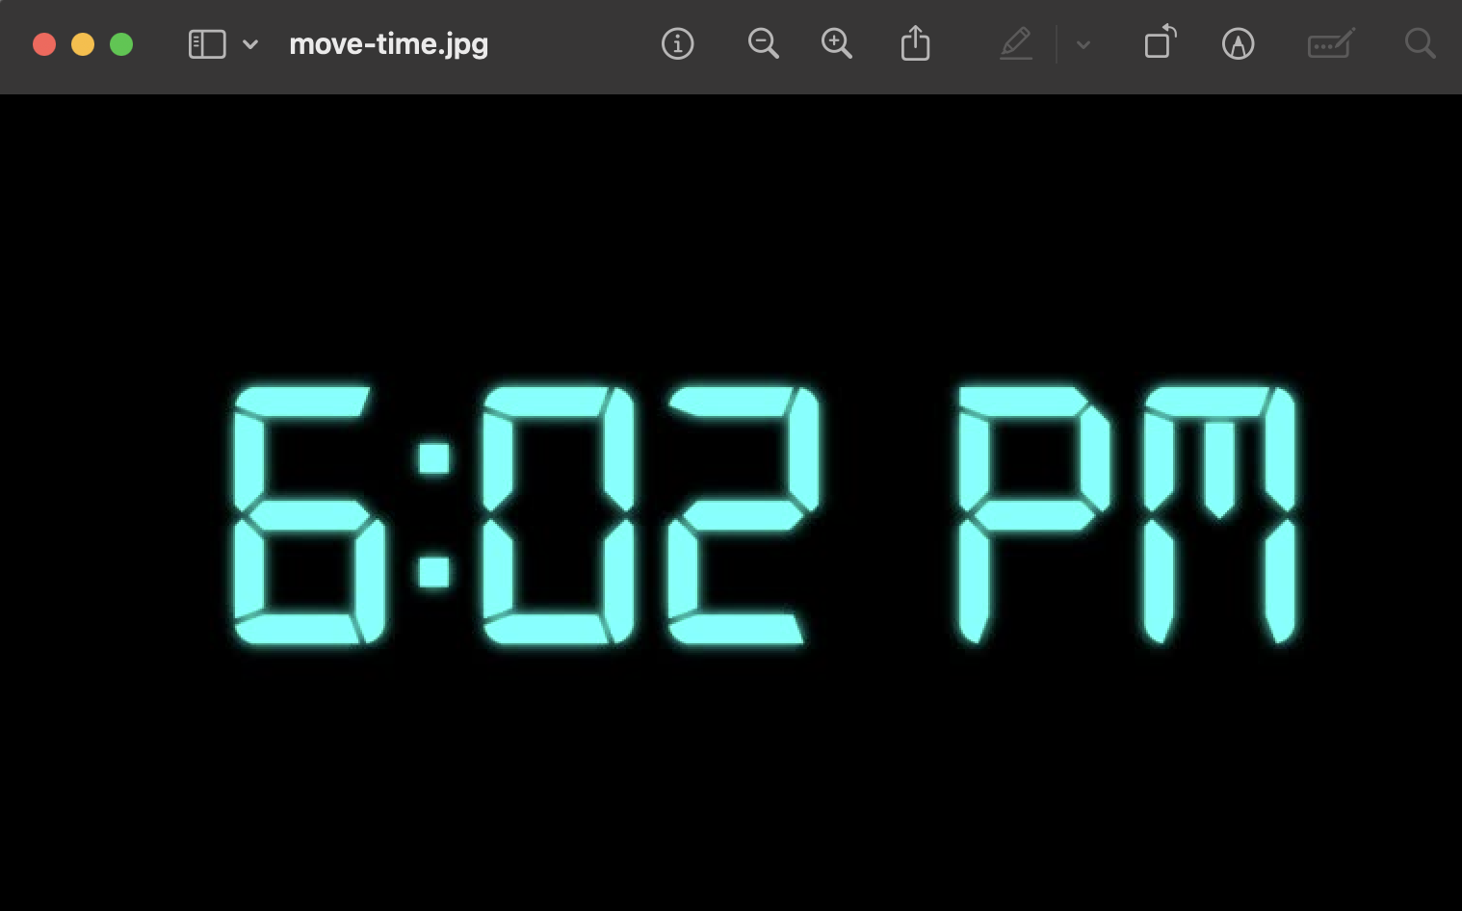

room_number.jpg (in registrar)

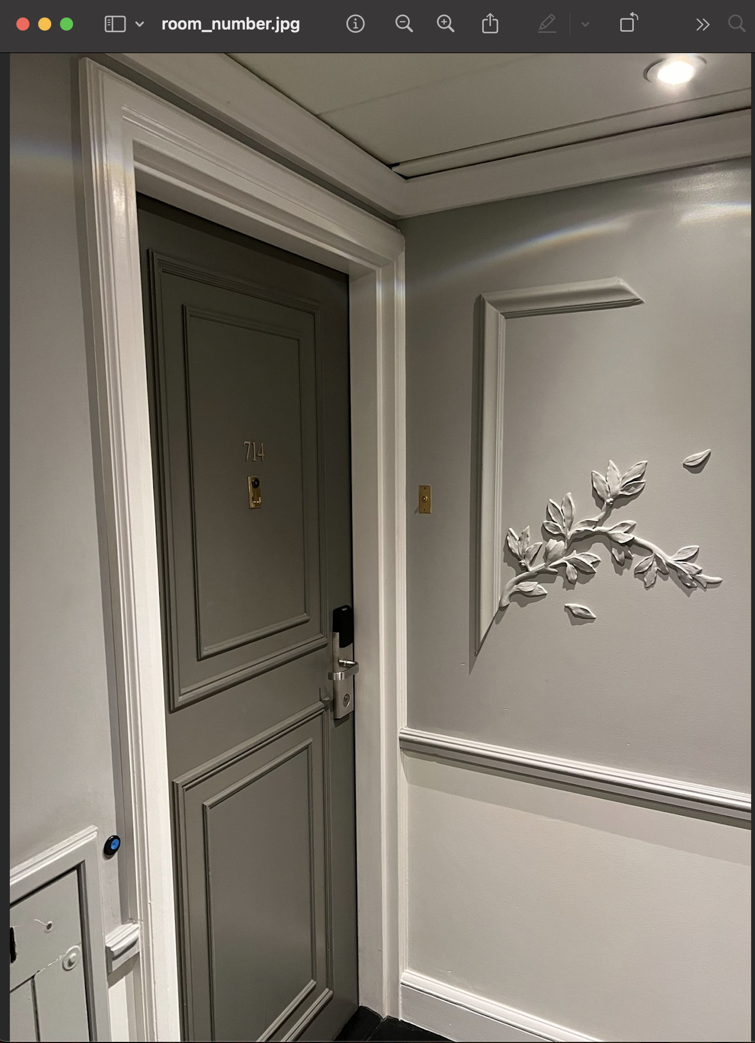

sema_martin.pdf

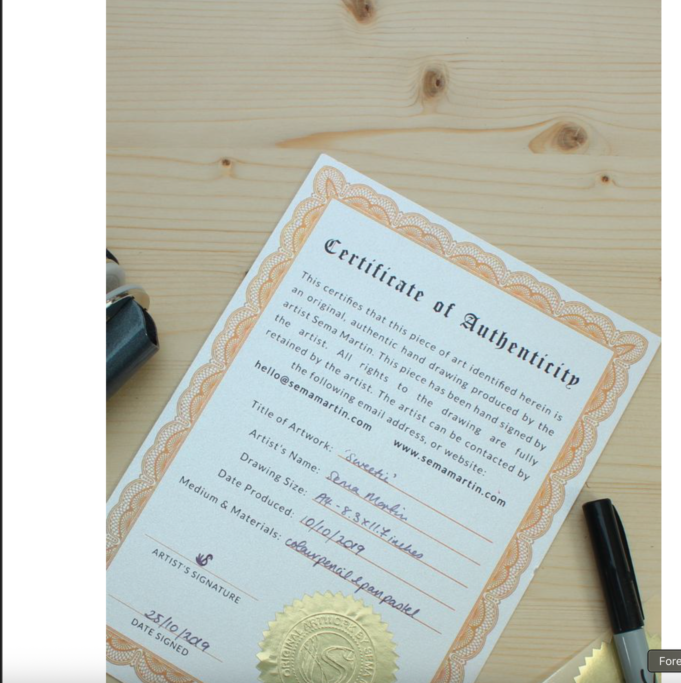

# List of Tables

|  |  |  |  |  |  |
| --- | --- | --- | --- | --- | --- |
| Disk Information | Reserved Area | 1st FAT area | 2nd FAT area | Root Discovery | Data Area |
| 0-2048 | 2048-2052 | 2052-2152 | 2152-2252 | 2252-2284 | 2284-104448 |

|  |  |  |
| --- | --- | --- |
| File | Confirmation Command | Recovery Command |
| Bastile.png | hexdump -C -s $((2288*512)) -n ((2656*512)) case201_investigation_disk.dd | dd if=case201_investigation_disk.dd of=Bastile.png bs=512 skip=2288 count=2656 |
| Registrar.zip | hexdump -C -s $((4944*512)) -n ((402*512)) case201_investigation_disk.dd | dd if=case201_investigation_disk.dd of=Registrar.zip bs=512 skip=4944 count=402 |
| Cert.zip | hexdump case201_investigation_disk.dd -s $(( 210944*512 )) -n $(( 288*512 )) | dd if=case201_investigation_disk.dd of=Cert.zip bs=512 skip=210944 count=288 |
| Location.txt |  | dd if=case201_investigation_disk.dd of=location.txt bs=512 skip=$((53560656+8)) count=512 iflag=skip_bytes,count_bytes |

|  |  |  |
| --- | --- | --- |
| File Name | Starting Offset | Ending Offset |
| Bastile.png | 1171456 | 2531328 |
| Registrar.zip | 2531328 | 2738176 |
| Cert.zip | 53559296 | 53559716 |

# 1 Detailed Analysis of Partition Allocation

There are two partitions in the image. One is FAT16 and one is NTFS. The sectors before the FAT16 partition are 2048 and the sectors before the NTFS are 104448. Below is an image of the partitions with the descriptions of where the partitions start and end.

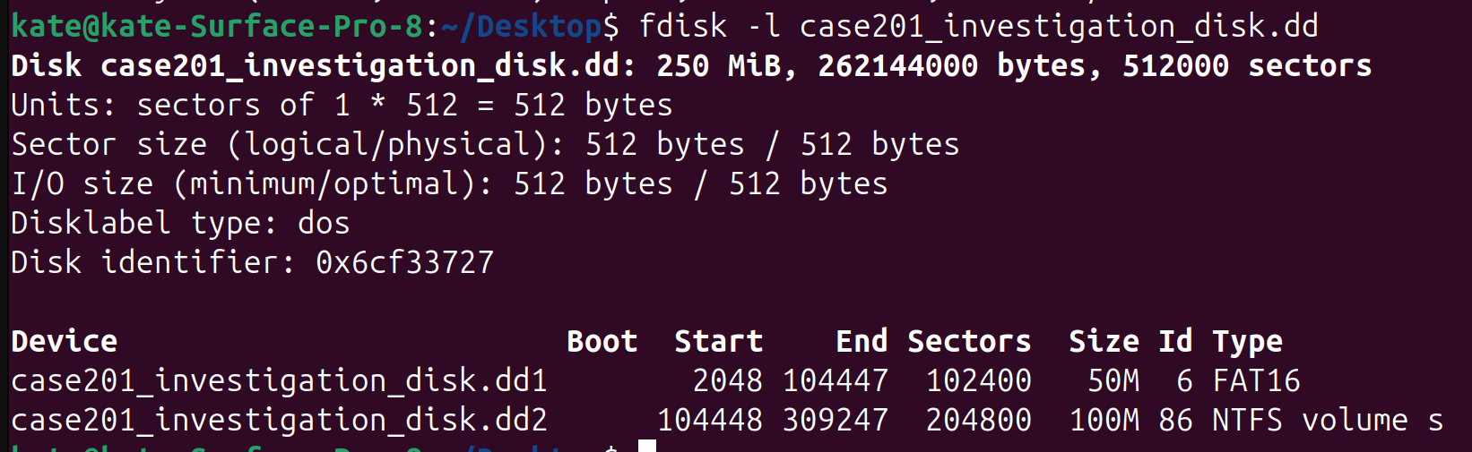

# Partition 1

I was able to see the disk information by typing in the following command “hexdump -C –s $((2048*512)) -n $((512*1)) case201_investigation_disk.dd”. I found the bytes/sec by looking at the location 000Bh for 2 bytes which is 0002 then do big endian and it is 512(0x0200).

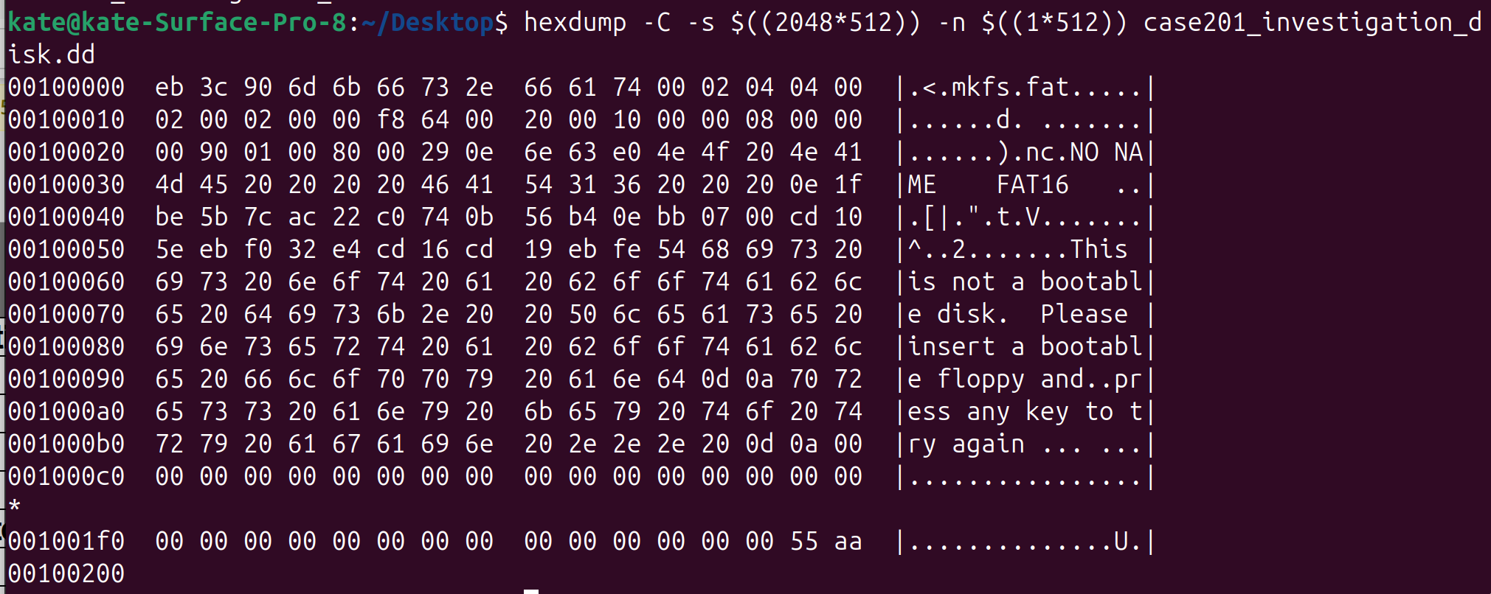

I found the number of sec/cluster by looking at the location 000Dh for 1 byte which is 04. In decimal it is the same so the answer is 4.



I found the reserved sectors by looking at the location 000Eh for 2 bytes. It is 0400 adn when you do big endian you get 4 (0x0004).



I found the sec/fat by looking at location 0016h for 2 bytes. It is 6400 and when you do big endian endian you get 100 (0x0064).



## Partition 2

The 2nd partition is NTFS so the analysis will look a little different. To find our information we need to use Disk Editor. The 2nd partition starts at 104448 so lets start there. The bytes/sec is 512. The sec/custer is 8. The are 0 reserved sectors. The $MFT Cluster Start is 4 and the $MFTMirr Cluster Start is 12799. The #System $MFT Records is standard at 39 and the $MFT Record Size is also standard at 39.

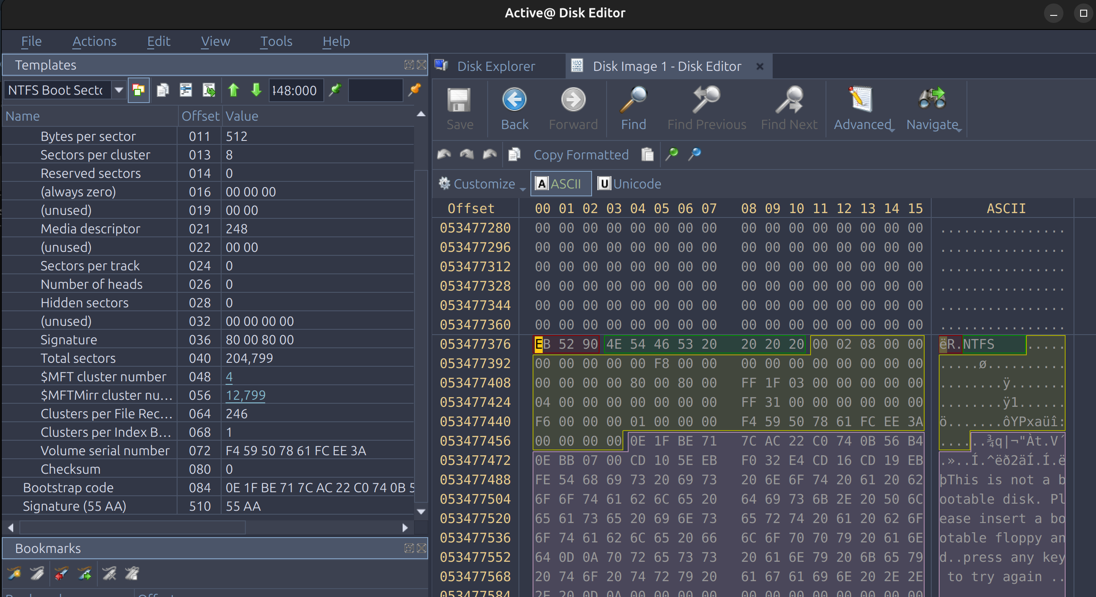

## Detailed Analysis of the Recovery Process

After the disk information is analyzed for the first partition, look at the file allocation table and the root directory. The file allocation will show how many buffers you have between he beginning of the data area and the start of the file location. Then look at your root directory, This will say how many files are on the partition, the size of the file, and the status of the file.

For the NTFS partition, after we look at the boot sector we can calculate where the file information is in the MFT. From the MFT it shows the status of the file, the size of the file, and the characteristics of the file.

### 2.2.1 Partition 1 File 1

First take a look at the partition 1 allocation table. This will inficate the size of the buffer. This is crucial because if it is ignored file carving will be done incorrectly and result in incorrect files. The size of the buffer is found by the number of clusters that are found before the files start. The screenshot below shows that there is 1 cluster. Then you multiply it by how many sec/cluster which is 4. 4*1=4

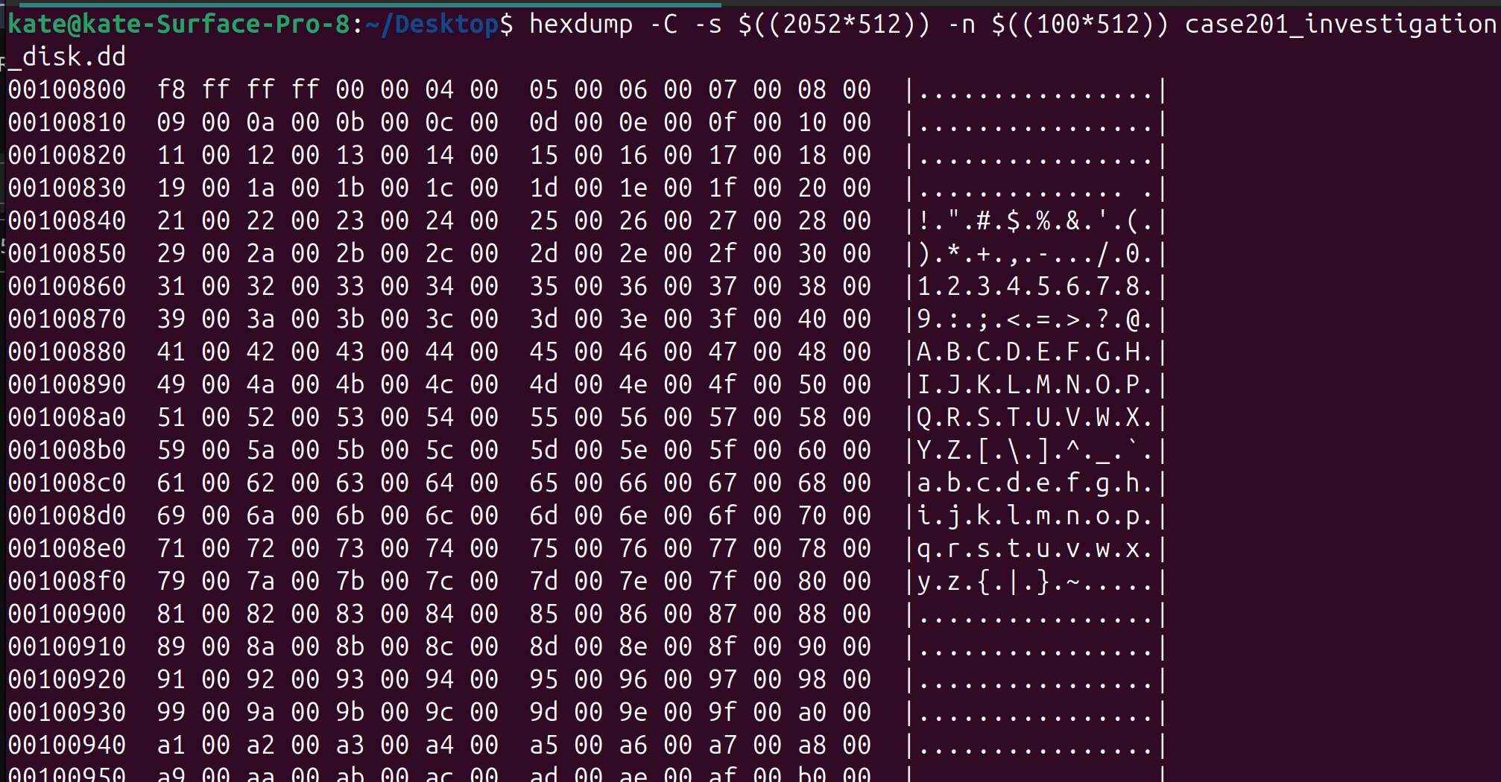

Next is the see what files aare on the partition by looking at the root directory. This shows the number of files and their sizes. Below shows that there are 2 files. The first is called Bastile.png. The file status is 41 which indicates that it is an active file. To find the file size look at the last 4 bytes and perform the big endian operation on them. The last 4 in this case are 2e bf 14 00 so after the big endian it is 00 14 bf 2e which is 1359662. Then to find the number of sections divide that number by 512 so 1359662/523 = 2656.

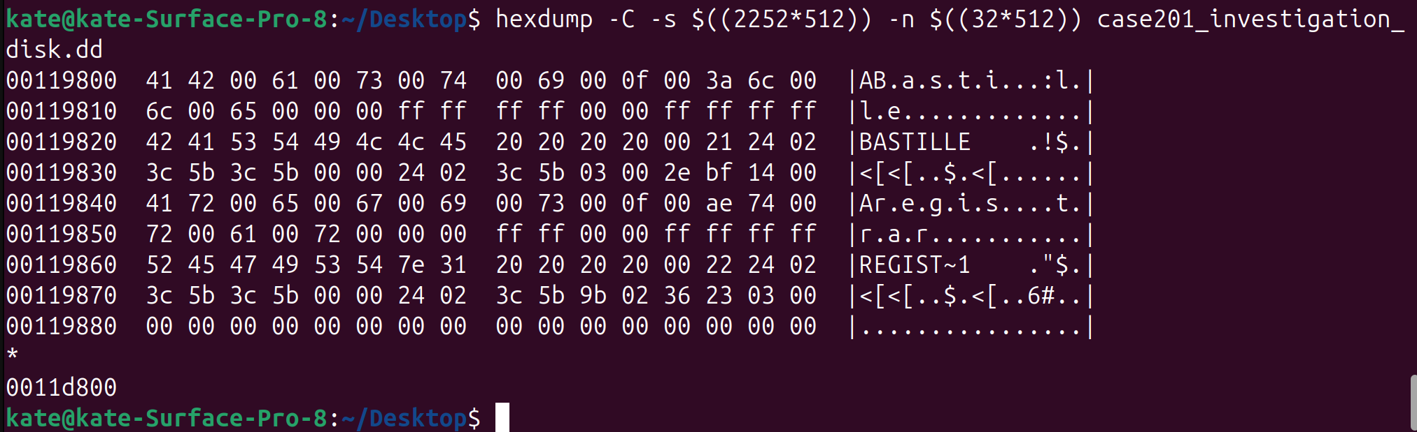

Now to carve the file. We have to calculate what to skip which is 2048 + 4 + 100 + 100 + 32 + 4= 2288. So use the dd command to carve it. Type in the following “dd if=case201_investigation_disk.dd of=Bastile.png bs=512 skip=2288 count=2656”

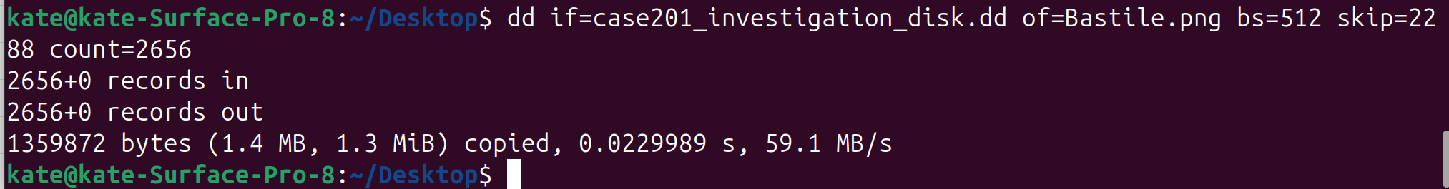

Below is an image of the file that we carved.



### 2.2.2 Partition 1 File 2

This is on the same partition so we already know that the data buffer is 4 so now it is time for analysis of the root directory. The next file is called registrar.zipTo find the size we need to look at the last 4 bytes of the file. The bytes are 36 23 03 00 so after the big endian it is 00 03 23 26 (205622). To find the number of sections divide that number by 512 so 205622/512. To find where the file is located add up all of the things that came before so 2048 + 4 + 100 + 100 + 32 + 4 + 2656 = 4944.



To carve the file we need to use dd so use the following command dd if=case201_investigation_disk.dd of=registrar.zip bs=512 skip=4944 count=402. Below is that command.

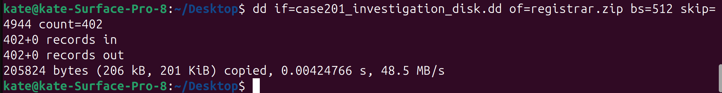

Inside the zip folder there are 2 files move-time.png and room_number.jpg. First is move-time and then second is room_number below  
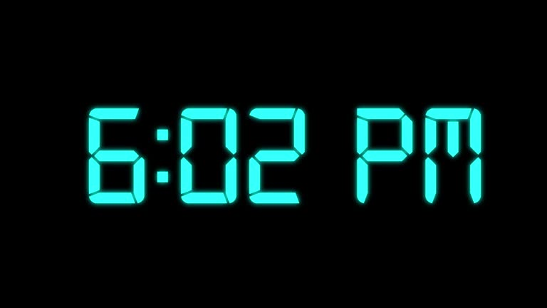

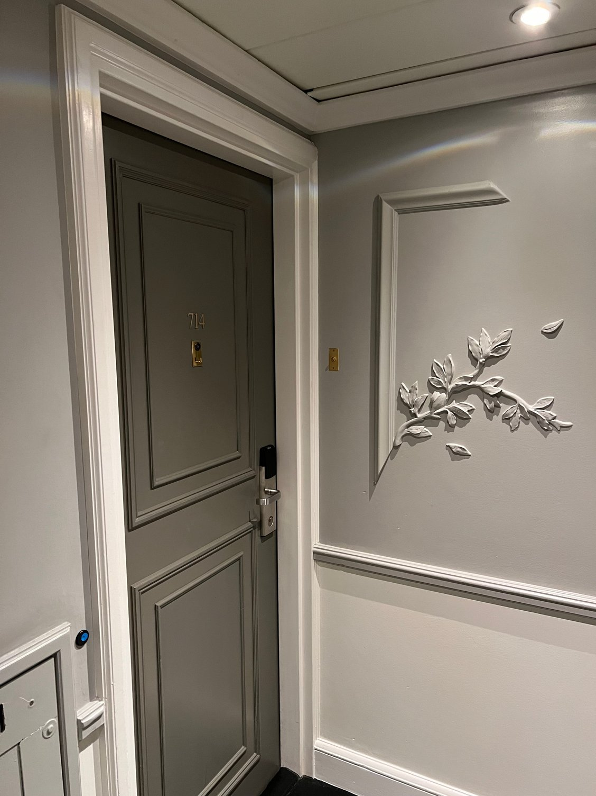

### 2.2.3 Partition 2 File 3

I ran into some issues with the NTFS partition. I calculated that to sectors to partition was 104448 because earlier when we ran fdisk it showed that was when partition 2 begun. Then the $MFT Cluster Start is 32 sectors because it is 4 clusters and the sec/cluster is 8 so 8*4 = 32. I assumed that the $MFT System Records in sectors is 78 like in class because that is standard for NTFS. So after I added up the sectors to the file I got 104448+32+78 = 104558. In Disk Editor I went there and there was no file. I went back through my calculations and did not find any errors. I went ahead and scrolled through the MFT until I found Cert.zip. Cert.zip is located at sector 104608. After I found that I thought that it was just blank data until the file appeared. Once I found the file I looked through and saw that it was in use and non-resident so I did not have to do cluster carving. The first cluster is 13312 so multiple that by 8 and get 106496 so that is the first sector. Then add the 1st sector plus the stuff before which is 106496 and you get 210944. The number of cluster is 36 so multiple that by 8 and you get 288 which is the number of sectors. It has had $50 which I learned what a security attribute so you could tell the file was password protected.

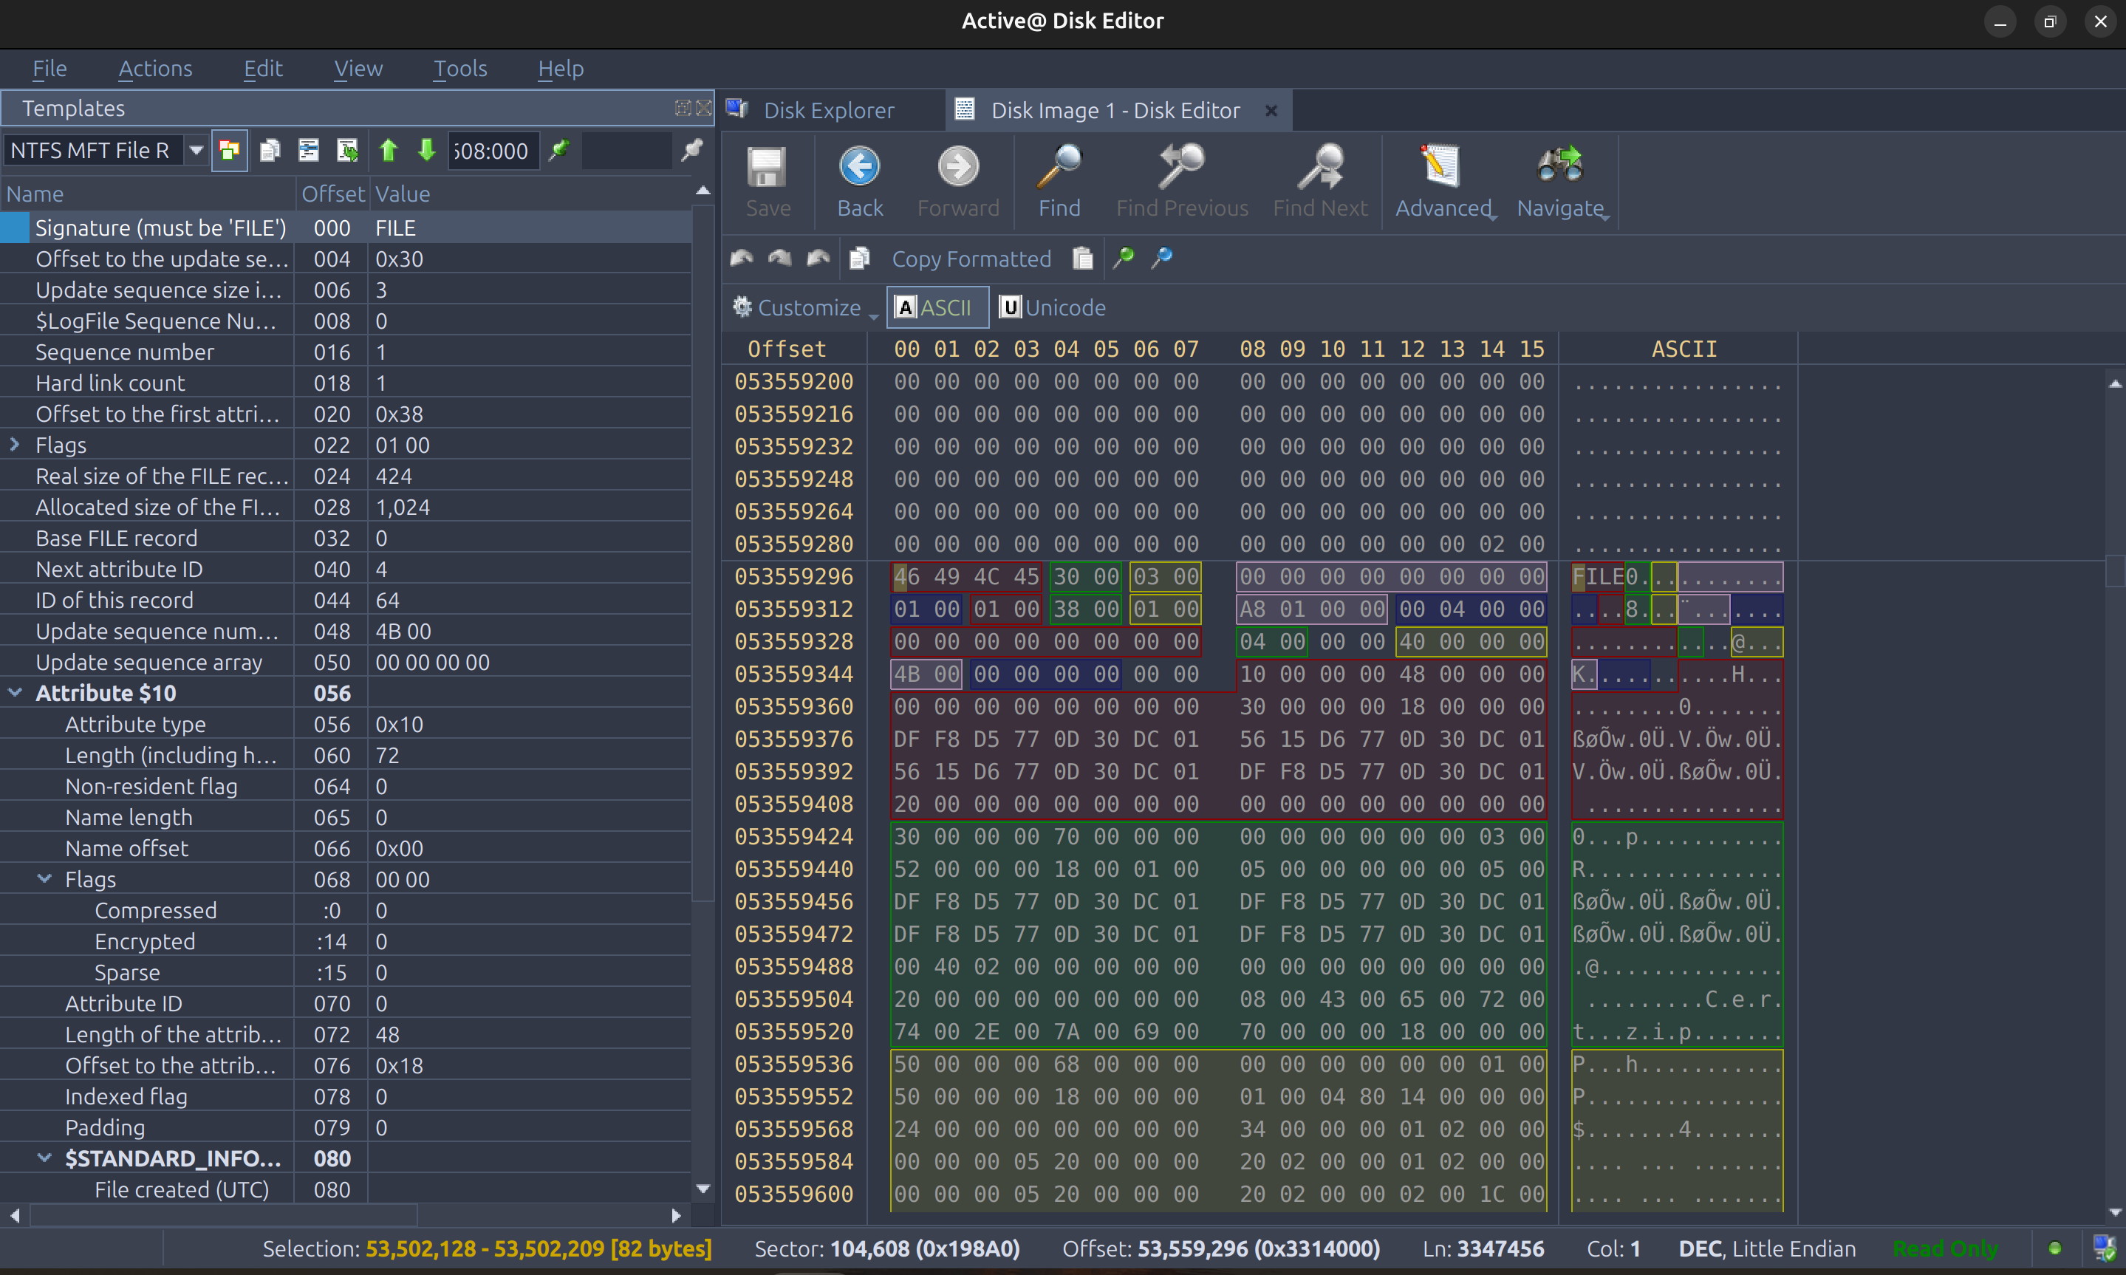

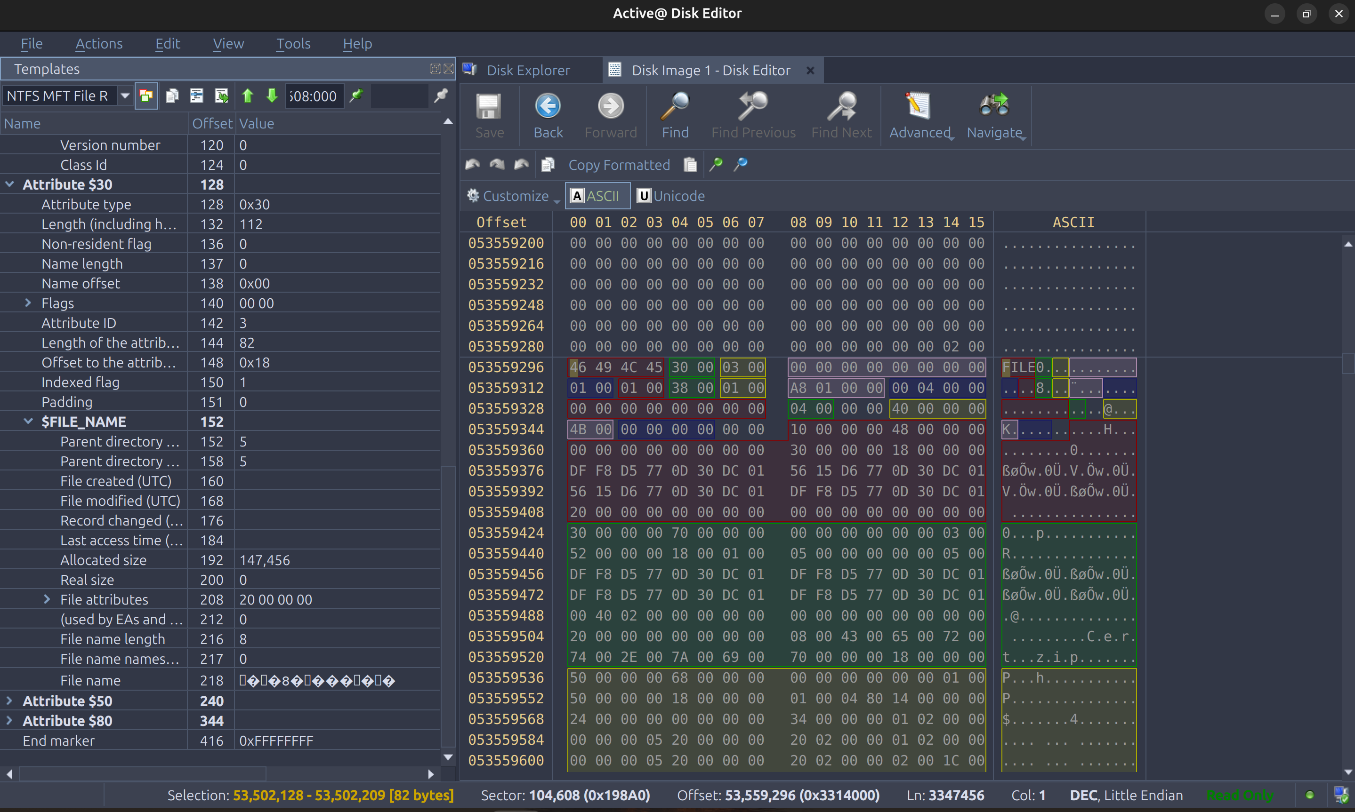

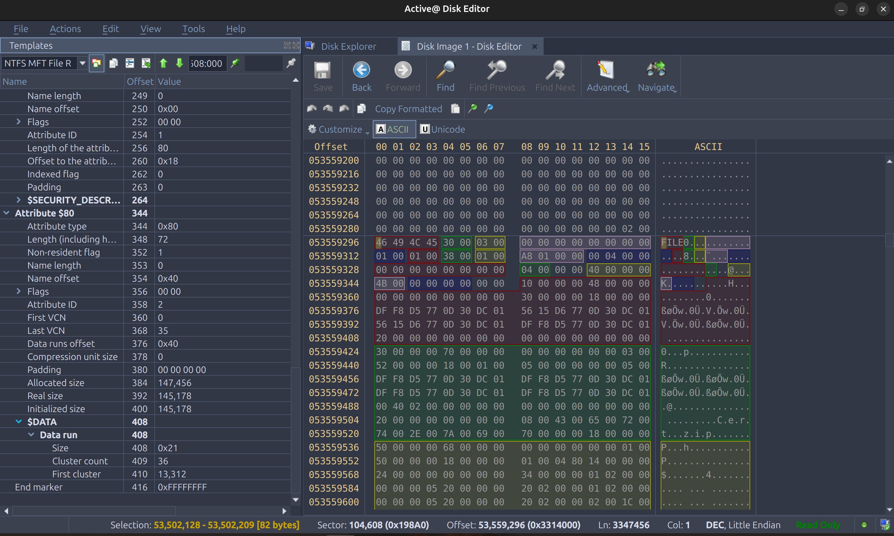

The Cert.zip file was password protected but the clue in the instructions said that it was the zip code from the restaurant. So I looked up the coordinates for the Bastile restaurant and found the zip code which was 75004.

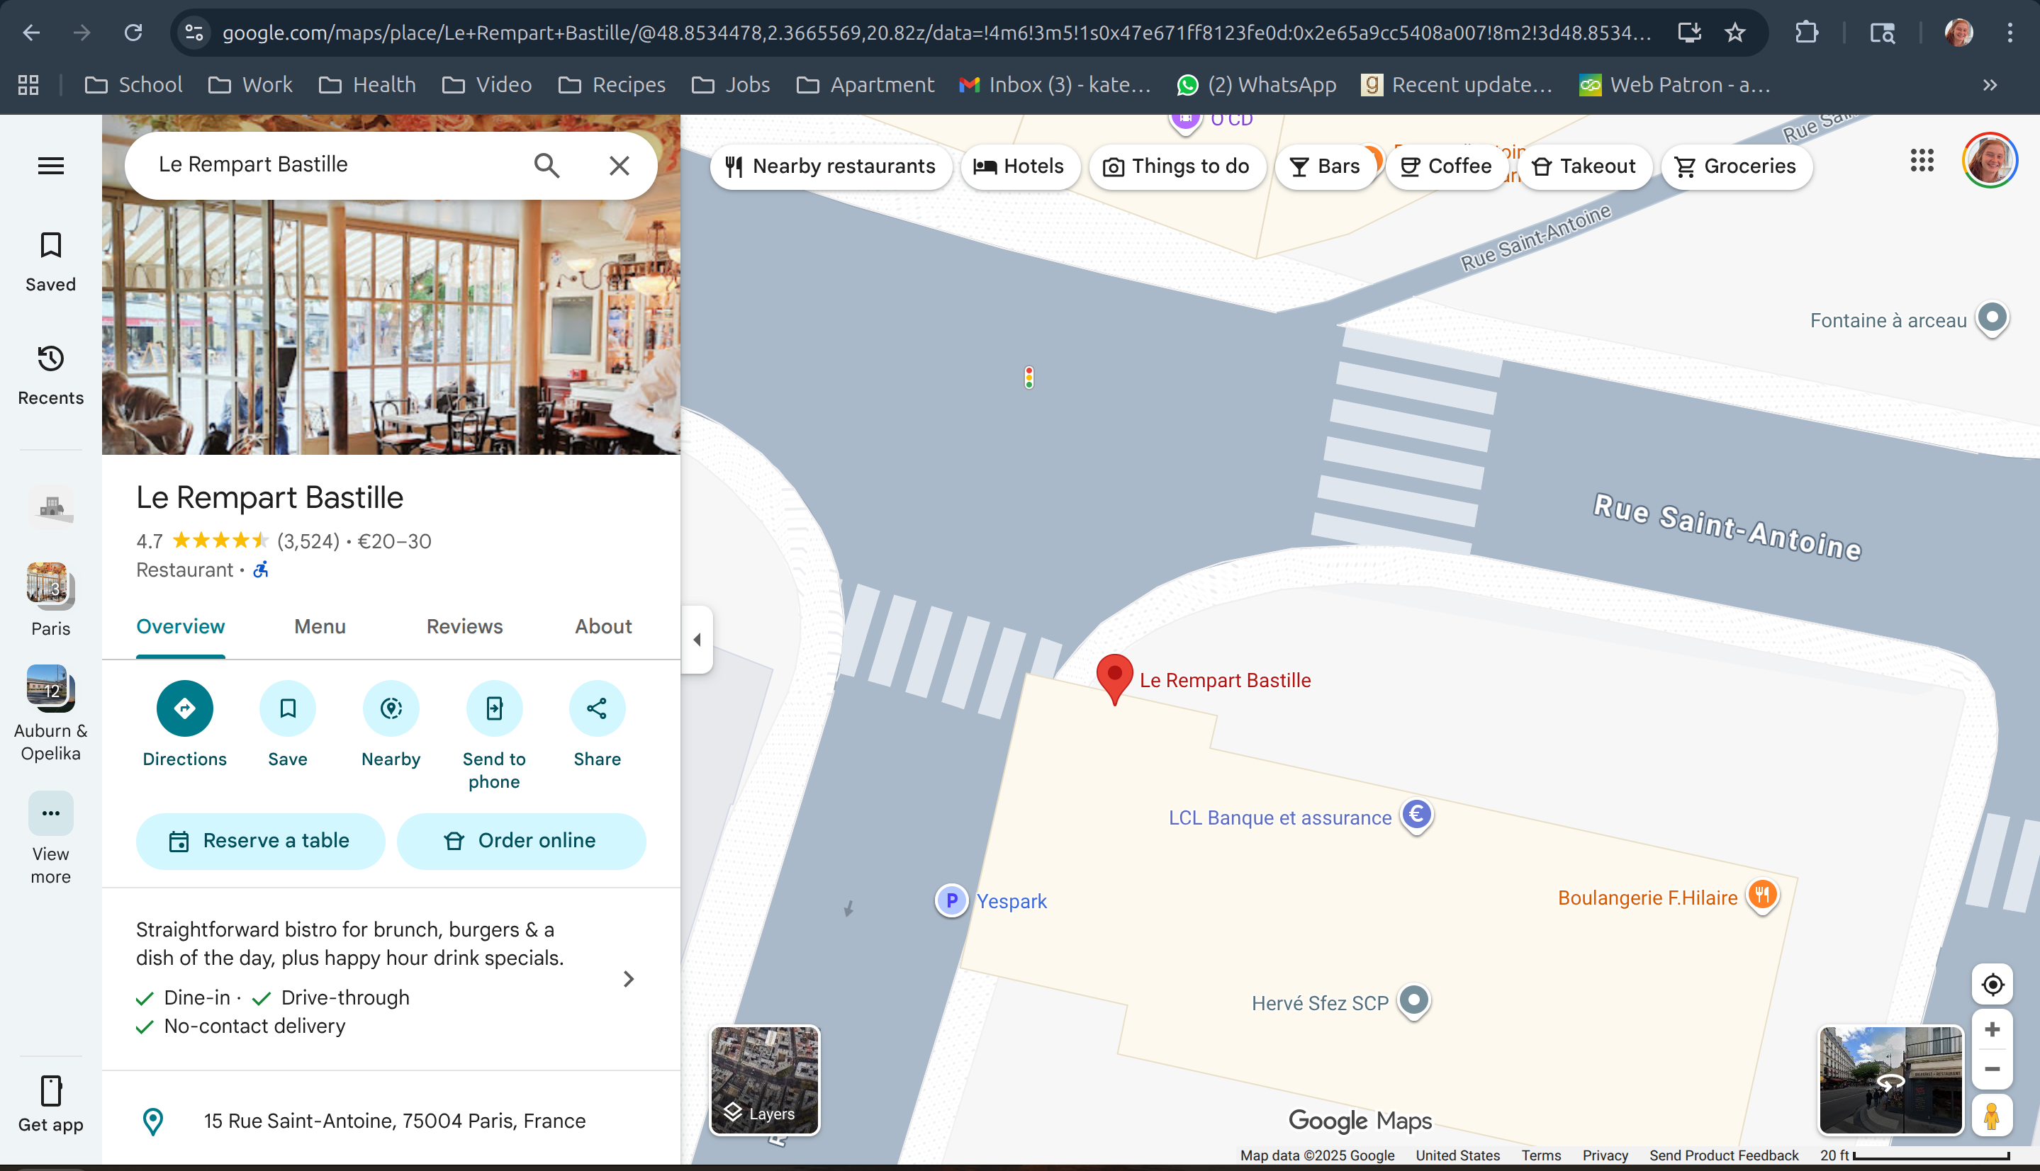

After I entered the zip code and unzipped the file. I saw a sema_martin.txt file but it would not open so I ran the file command on it and it showed that it was a pdf file so I renamed it sema_martin.pdf and it opened the certificate.





### 2.2.4 Partition 2 File 2

I continued to scroll down and saw that there was another file called location. I saw that is was a non-resident file. So I attempted to carve it via clusters. I do this dd command but it came back with errors so I believe I did it incorrectly. dd if=case201_investigation_disk.dd of=location.txt bs=512 skip=$((53560656+8)) count=512 iflag=skip_bytes,count_bytes

# 3 Description of Analysis Techniques Utilized

During the midterm the use of fdisk to analyze the disk image to see how many partitions there were and what type were crucial. I used hexdump to see the hex and ascii results from the deserved sections for the FAT16, without this file recovery would not be possible. I used dd to carve the images with the exact location and size for both partitions. On the NTFS partition I mainly used Disk Editor. Taking use of the templates that are present are useful to quickly find file names, size, etc.

# 4 Results and Discussion

The results of the data recovery were 3 files. I attempted to get a 4th but was unable to. I was able to discover the restaurant the group met. The location of the registrar and the move time. I was also able to recover the image of the certificate. I was able to walk through the plan of the thieves and discover how they pulled it off.

# 5 Conclusions and recommendations

The midterm challenges the knowledge of both analyzing FAT16 partitions and NTFS partitions. The basic understanding of the structure was key to solving the puzzle. I think it would have been helpful to go over a non-resident file a little more and dive a little deeper. I think I am still growing my skills and have some more learning to do.

# 6 Acknowledgements

The lecture notes from Dr. K were used to aid in this assignment. The lessons on FAT16 and NTFS were used the most.

# 7 References

[1] “Decimal to hex converter [Internet]. RapidTables; c2025 [cited 2025 Sep 29]. Available from: <https://www.rapidtables.com/converter/number/decimal-to-hex.html?x=0>”.

# Appendix A: Place the title of appendix here

Provide appropriate appendices as necessary. Each appendix should begin on a new page.